**Project Title:**

Analysis of twitter using sentiment analysis

**Project Members:**

Sai Teja Balusu

Ajith Madala

Jai Sai Malakalapalli

Manideep Reddy Gadhe

* **MOTIVATION:**We can track the updates on the social media which will include markets ,product ,podcast ,political news and celebrity news, etc... and will detect the positive and negative in tweets in the social media like twitter, posts or comments which we will prevent from surge.
* **SIGNIFICANCE:**We chose twitter because sentiment analysis in twitter, which can provide data which will include the expressions of the people like, feelings, views on particular topic, monitoring’s on different things and arguments. So, by taking the data, you can find different interests and behaviours of society and helps the tool to improve working.
* **OBJECTIVES:**The objective of this project is to get the opinion of the people on different topics which is in trending or focused in particular topic. So, we can analyse the text from different sources to provide the sentiment analysis on various topics by the help of hashtags.
* **FEATURES:**It is automating the categories of the sentiments of messages posted in twitter by resisting and fixing the different kinds of tasks which has characters restrictions, unnatural styles of writings, etc...

• **Related Work (Background):**We used data processing on the text and after that we send the data to sentiment classifier to get the sentiment of data. We may not be able to get the accuracy, but the relative probability of complete data will be sufficient to understand the sentiment of given tweet.

• **Dataset:**We will run twitter authentication and use tweepy to request 2500 tweets for each tag. So, we will test and train the data in dataset to make it easy for the system to go through the data without null value.

• **Detail design of Features:**It is to understand the sentiment of people on particular topic to predict the rate of positives and negatives to deliver better customer assistance .

• **Analysis:**Not everyone has similar thinking on particular topic, so by considering this we can grasp. The trend of people’s opinion on various topics if we go through the topic which can get the general trend of complete population,

Example: In a tournament people may give support one team while the tournament going on if the team cannot perform well, so the opinion of people will vary by situation so we can grasp the people’s opinion in present criteria but we cannot predict the future.

• **Implementation:**

Import:

Sys:(access the system specific functions and parameters),

Tweepy:(accessing twitter API),

Matplotlib:(plot graphs),

Pandas: get data to respective environment.

NumPy: Numerical Expressions.

Os: interact with operating systems to operate a folder.

nltk: Natural language tool kit to program with human language data.

pycountry: Operate the databases.

re: it’s a regular expression.

String: Functioning standard python strings.

**Steps involved:**

1. Install packages and import libraries.
2. Authentication of twitter API’S.
3. Now we need to calculate paraments like compound, polarity , positive , neutral and negative by using text blog and get text you need to use tweepy.
4. Getting tweets with hashtags,
5. Here you need to press a keyword and no of tweets to

get the sentiment analysis based on [TOTAL, POSITIVE,

NEUTRAL, NEGATIVE] in the form of percentages.

1. To represent it we use barographs, pie charts, etc...

• **Preliminary Results:**

**Importing libraries:**

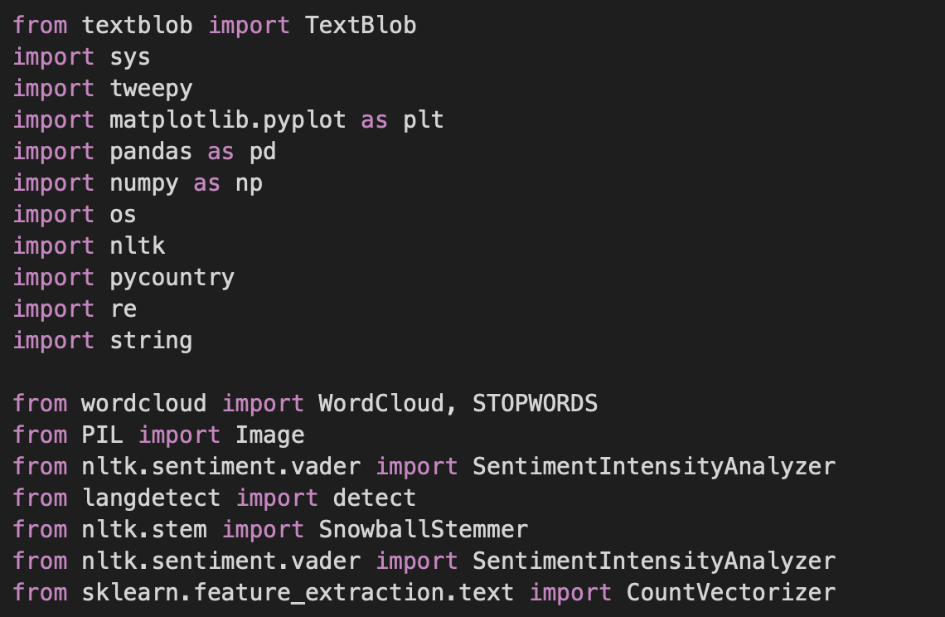

**Authentication:**

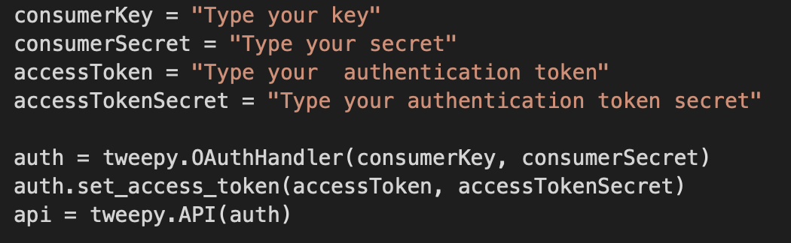

**Sentiment analysis:**

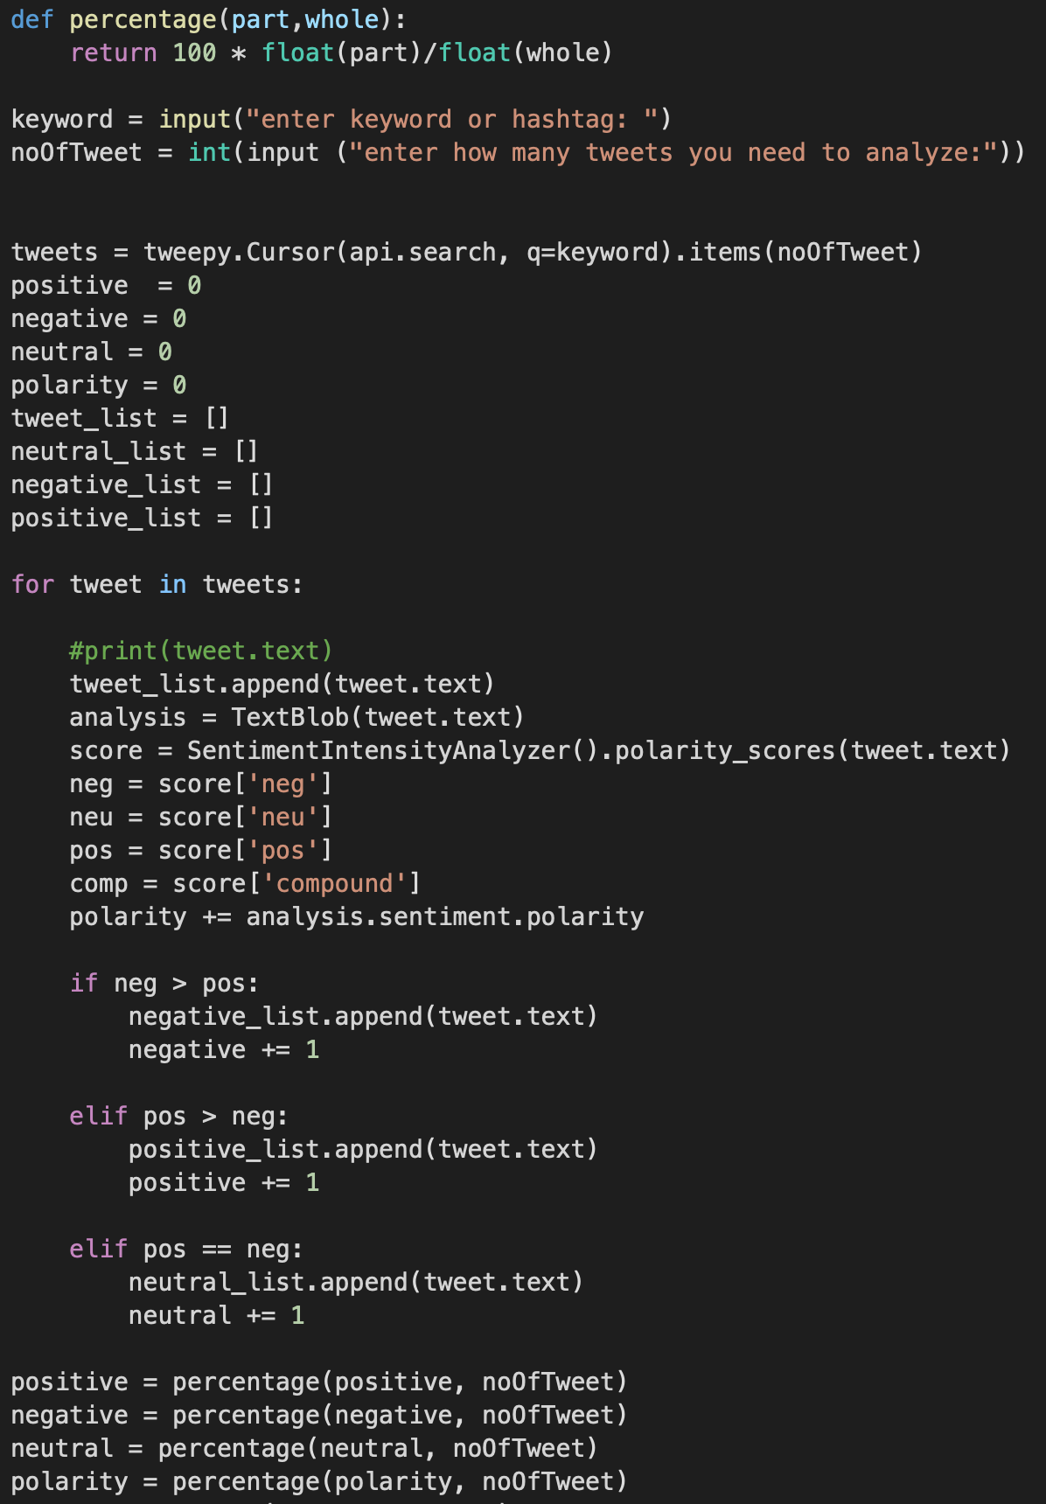

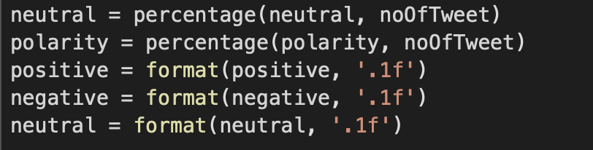

**Representing No of tweets:**

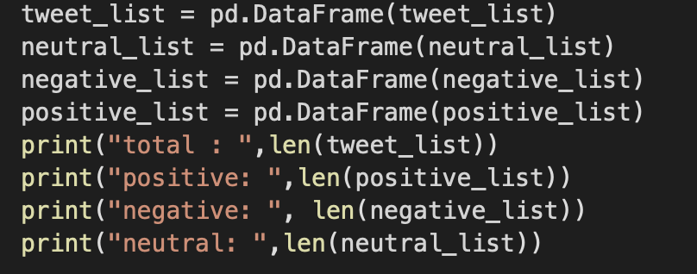

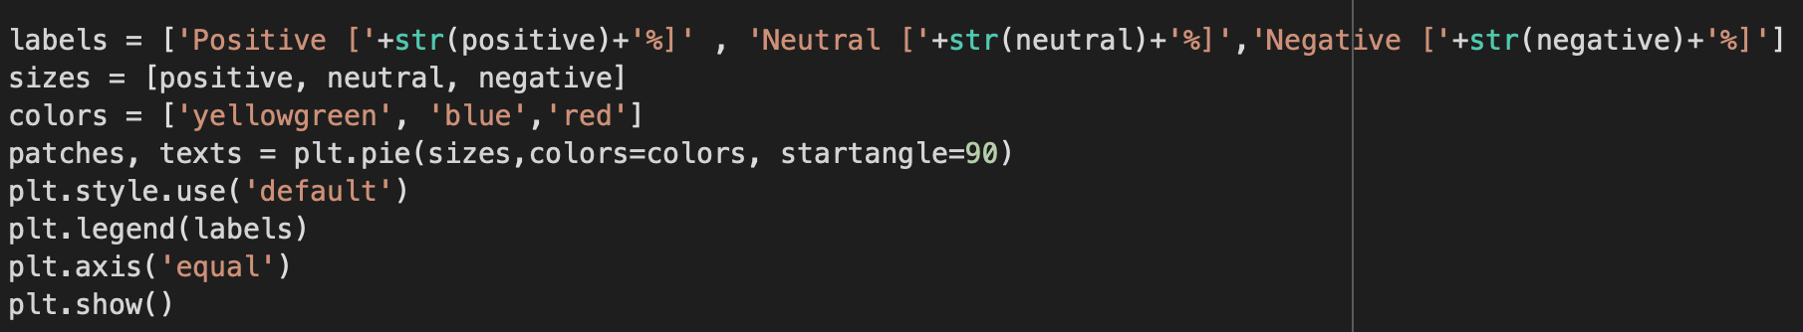

• **Project Management:**Here we are taking raw data from twitter and we are performing simple text processing using text blog and tweepy. We use positive, neutral and negative from the processed text data to get the output i.e., view of people on different topics. We are using twitter as base because of its loyal customer base who tweets every day on current topic which provides a lot of data.

**IMPLEMENTATION STATUS REPORT.**

* **WORK COMPLETED:**

Authentication of Twitter, Data Processing, Trend Estimation

* **DESCRIPTION:**We will gather data for twitter using hashtags and test and train the data, analyse the data and finding the present trends of positive, neutral and negative.
* **RESPONSIBILITY:**I. Sai Teja Balusu ----------------Data Processing

II. Rakesh Nath Dhulipalla ---- Data Visualization

III. Jai Sai Malakalapalli ---------Twitter Authentication

IV.Ajith Madala-------------------Testing and Training Data

* **CONTRIBUTIONS:**I. Sai Teja Balusu ----------------25/100

II. Ajith Madala ------------------25/100

III. Jai Sai Malakalapalli --------25/100

IV.Manideep Reddy Gadhe----25/100

* **WORK TO BE COMPLETED:**

Modifying the code to get more accuracy and efficiently.

* **DESCRIPTION:**Using more words we will do the code
* **RESPONSIBILITY (TASK, PERSON):**I. Sai Teja Balusu --------------- increasing the probability

II. Manideep Reddy Gadhe ---- Finding ways to Improve efficiency of the code

III. Jai Sai Malakalapalli --------- testing different test cases.

IV.Ajith Madala-------------------Analyzing the references that may help in our project

* **ISSUES/CONCERNS:** 
  1. It is hard to get authentication from twitter.
  2. The data will vary every day which will impact the report
* **REFERENCES:**
* https://towardsdatascience.com/step-by-step-twitter-

sentiment-analysis-in-python-d6f650ade58d

* https://developer.twitter.com/en/docs/tutorials/how-to- analyze-the-sentiment-of-your-own-tweets
* https://www.geeksforgeeks.org/twitter-sentiment-analysis- using-python/

Git hub Reference Link :

<https://github.com/AjithMadala/Feature-Engineering>